**OpenStack Single Node Deployment**

Steps to install and configure OpenStack on Centos7.x Using RDO

**Requirements:**

Operating System: Centos 7.x -64 bit

Hostname:gb.com (steps below)

IP Address: 192.168.2.227

**Prerequisites:**

1.Minimum one network adapter with internet connection.

2.Virtualization should be enabled.

3.Enable the CentOS-Vault.repo under /etc/yum.repos.d (follow the steps below)

4.Disable Network Manager.

**Step1:** Setting Hostname

C:\Users\guru\Desktop\openstack\1.PNG

Check..

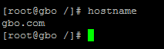

**Step2:** Enable the CentOS-Vault.repo under /etc/yum.repos.d

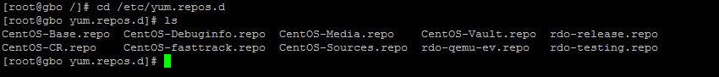

Edit the CentOS-Vault.repo as below.

C:\Users\guru\Desktop\openstack\8.PNG

After entering this command file opens like below and edit enabled =1 as below.

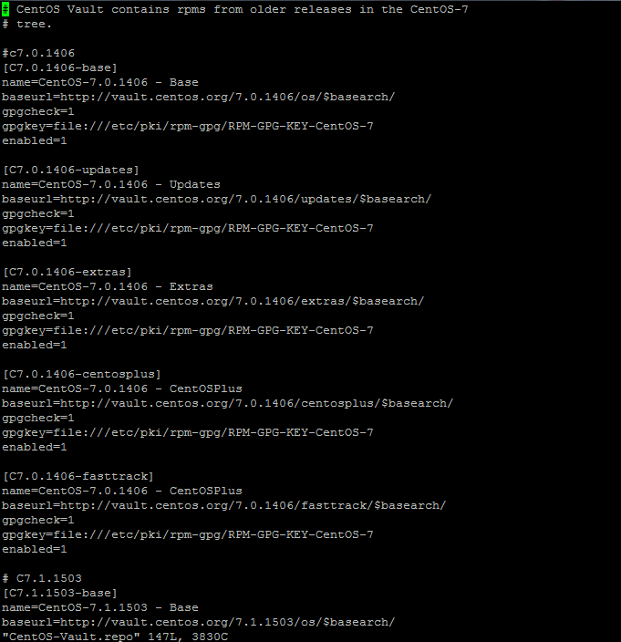

**Step3:** Disable Network Manager

C:\Users\guru\Desktop\openstack\14.PNG

Lets begin…

**Step4:** Install RDO Repository

Update the packages and install the RDO repository using below command.

C:\Users\guru\Desktop\openstack\3.PNG

C:\Users\guru\Desktop\openstack\4.PNG

RDO is RPM Distribution of Openstack . RDO is free distribution of redhat linux packages(CentOS,Fedora and RHEL)

**Step5:** Install the Openstack Installer “PackStack”

Packstack is a utility uses Puppet modules to deploy various parts of Openstack.

C:\Users\guru\Desktop\openstack\5.PNG

**Step6:** Deploy the OpenStack

PackStack can be used to install every OpenStack services on separate servers, an ‘all in one’ server, or any combination of these. There are three ways PackStack can be run.

1.packstack2.packstack [options]3.packstack --gen-answer-file=<file> [options] / packstack --answer-file=<file>

Third option allow you to generate default answer file , edit the default answer file , then run packstack a second time using this answer file.

C:\Users\guru\Desktop\openstack\11.PNG

Edit the answer.txt file to set the required parameters, we can customize which services to be installed using answer file as below.

C:\Users\guru\Desktop\openstack\12.PNG

Edit these parameters as shown below then save and exit

CONFIG_PROVISION_DEMO=n

CONFIG_KEYSTONE_ADMIN_PW=gb@123

CONFIG_NAGIOS_INSTALL=n

**Step4:** Install the OpenStack using answer file as below

C:\Users\guru\Desktop\openstack\13.PNG

Installation process take few minutes after installation is successfully completed it shows some paths where credentials are stored and also shows link to the dashboard, through that link you will able to access the dashboard by entering the credentials you will open the console as below…

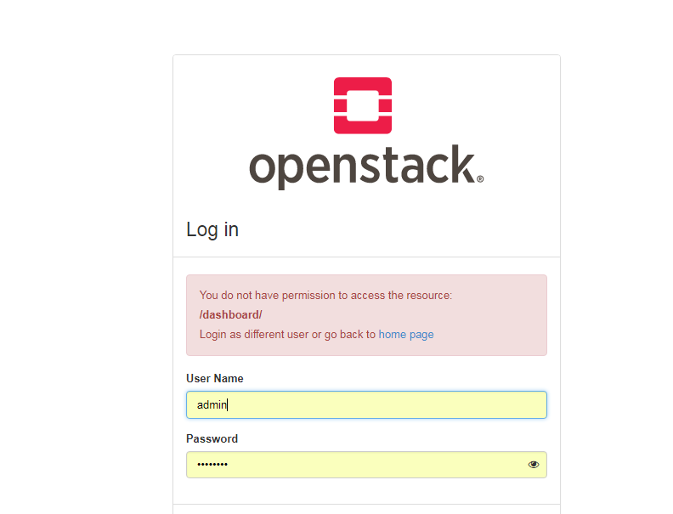

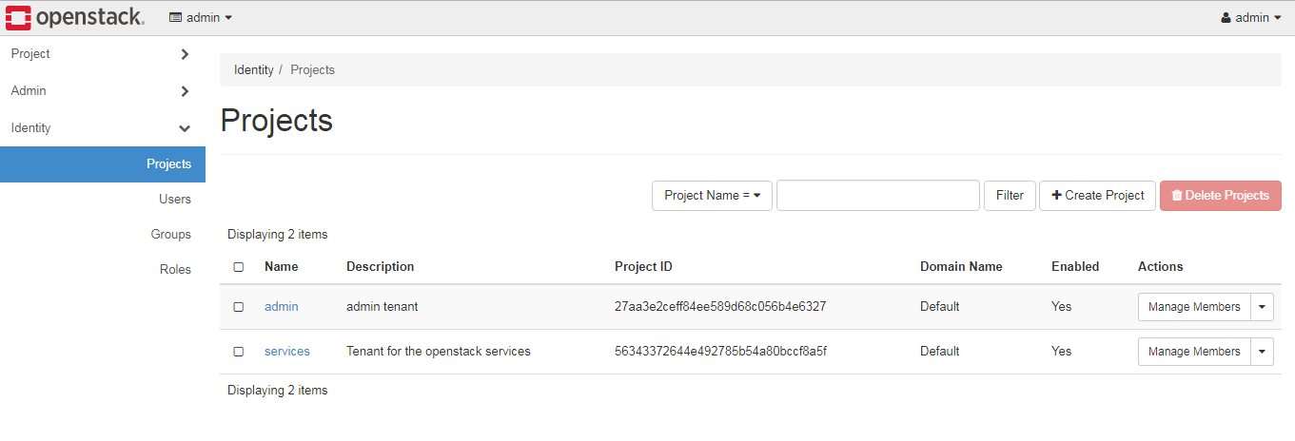

<<<<<<<<<<<<<<<<<<<<<<<<**THANK YOU**>>>>>>>>>>>>>>>>>>>>